1. Download Link: <https://autoitscript.com/site/autoit/downloads/>
2. Select the 64-bit version of windows
3. Right click on autoit-v3-setup.exe and click on Run as administrator

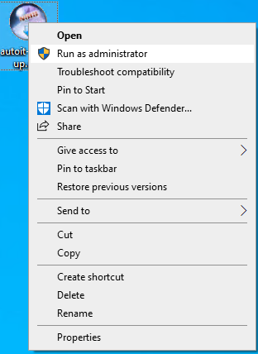

1. Click on yes

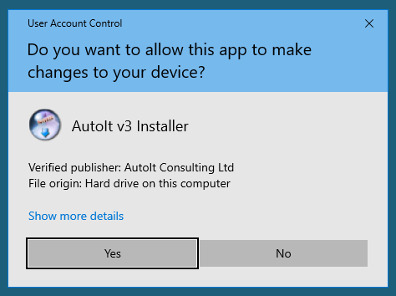

1. Click on next

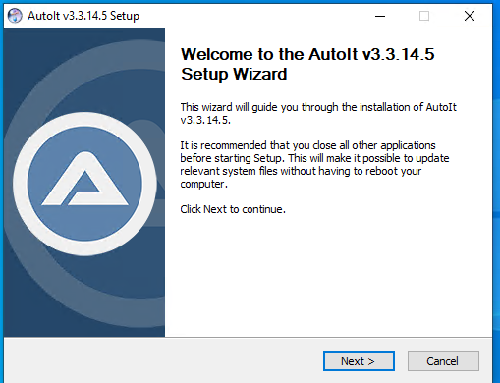

1. Click on I agree

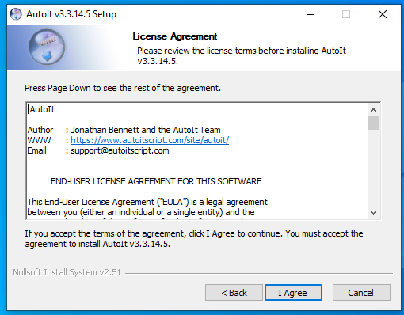

1. Click on Next

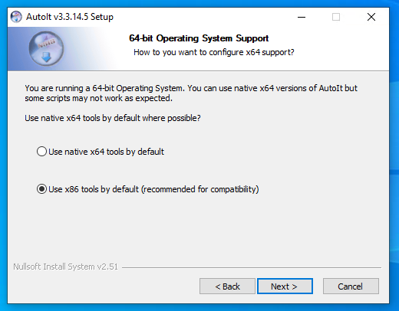

1. Click on Next

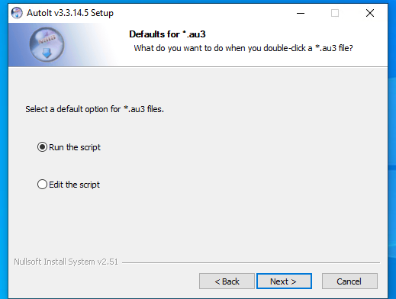

1. Click on Next

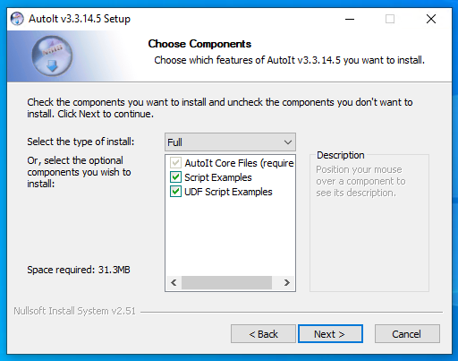

1. Click on Install

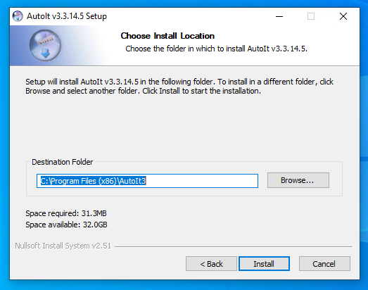

1. Wait for the process to complete

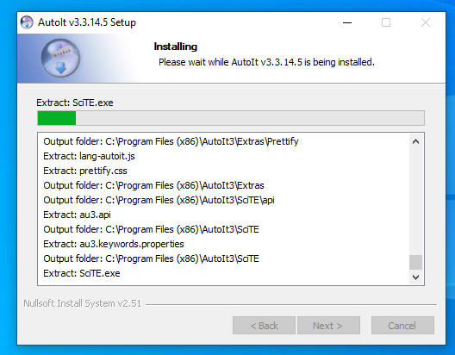

1. Click on Finish

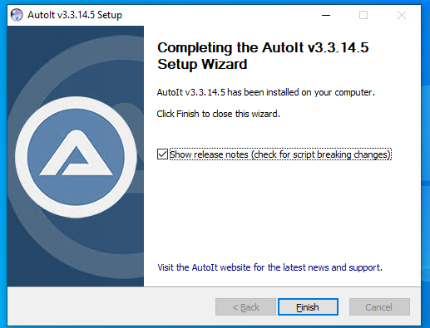

1. Close the release notes opened
2. Right click and click on new and see whether the context menu added or not

